Level 28 -> Level 29

The goal of this level is to access **a git repository at ssh://bandit28-git@localhost/home/bandit28-git/repo.** The password for the user bandit28-git is the same as for the user bandit28. We need to clone the repository at our local computer and find the password for the next level.

This level is same as level 28. Follow first three steps of level 28.

Steps to follow after completing first three steps:

1. Check the files present in repo.
2. README.md file is present. When we cat README.md file we found a text which shows the username as bandit29 and password as xxxxxxxxx.

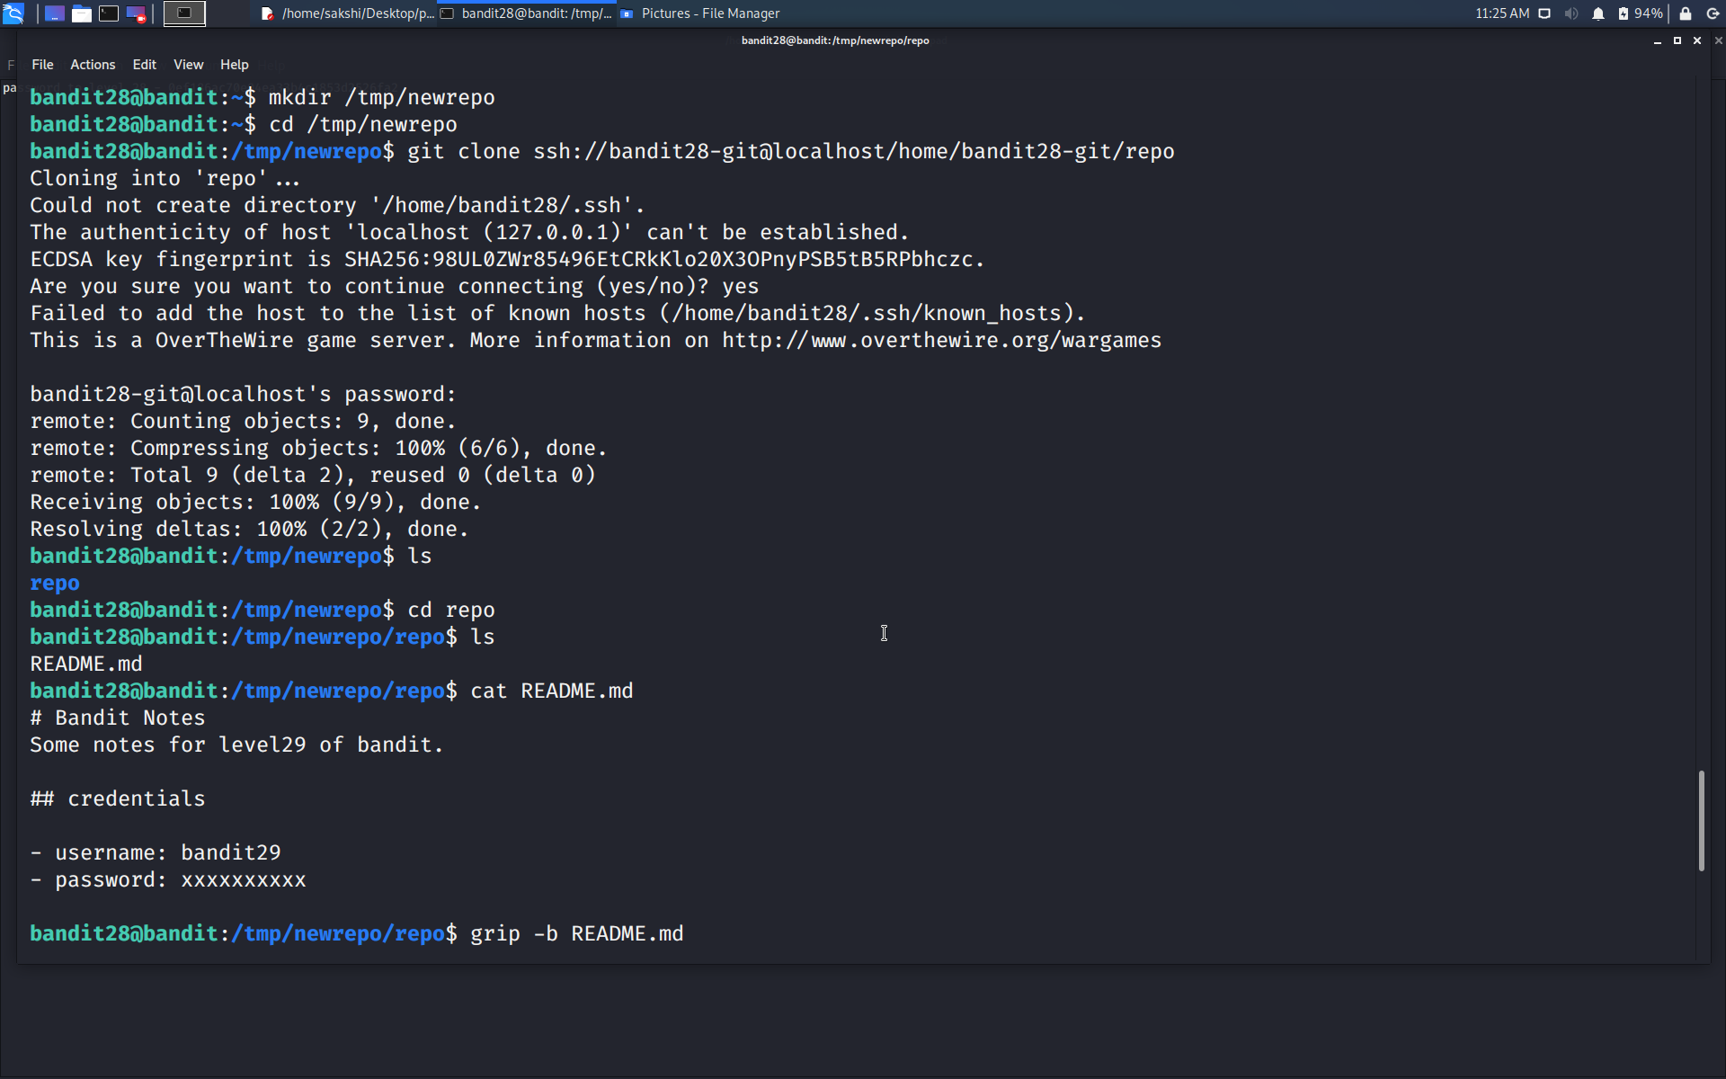

1. **Use git show** command to display objects like blobs, trees, tags and commits. We may find something in them.

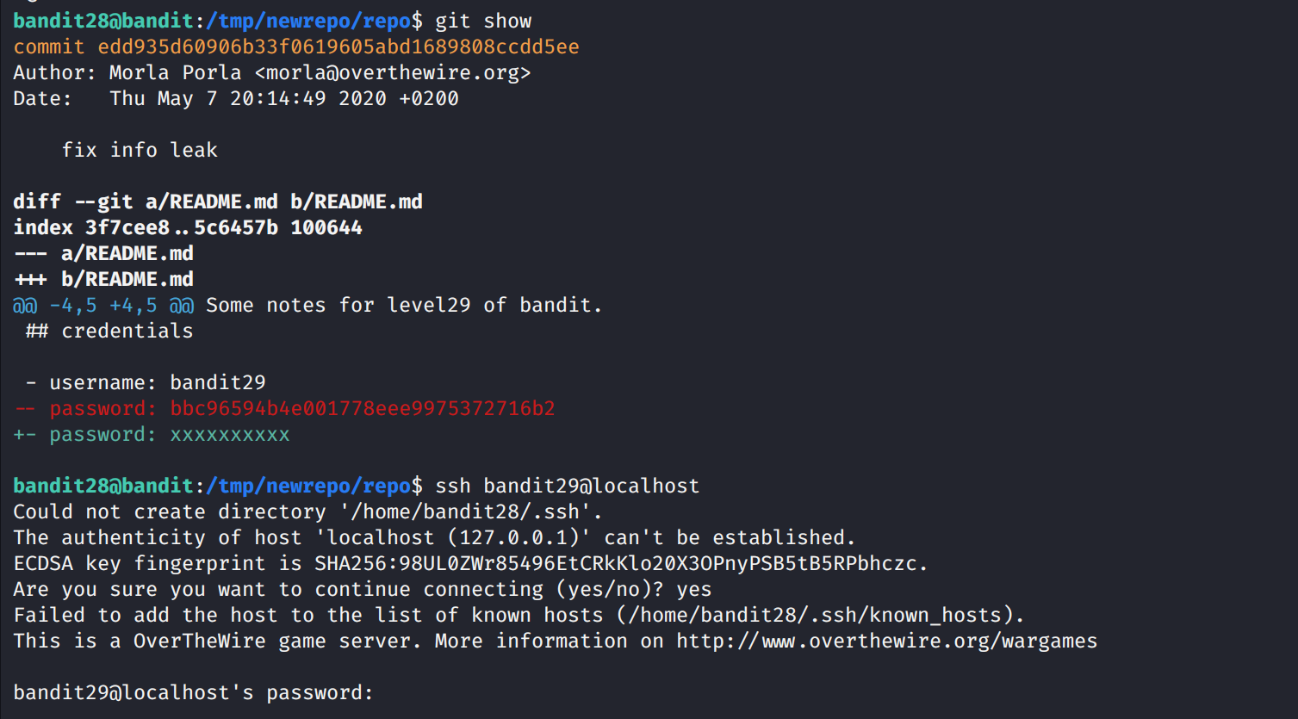

1. Yeah!!!! We got the password because it was recently commited.



Use the command **ssh bandit29@localhost** to connect to the level 29.

Enter the password and hit enter.

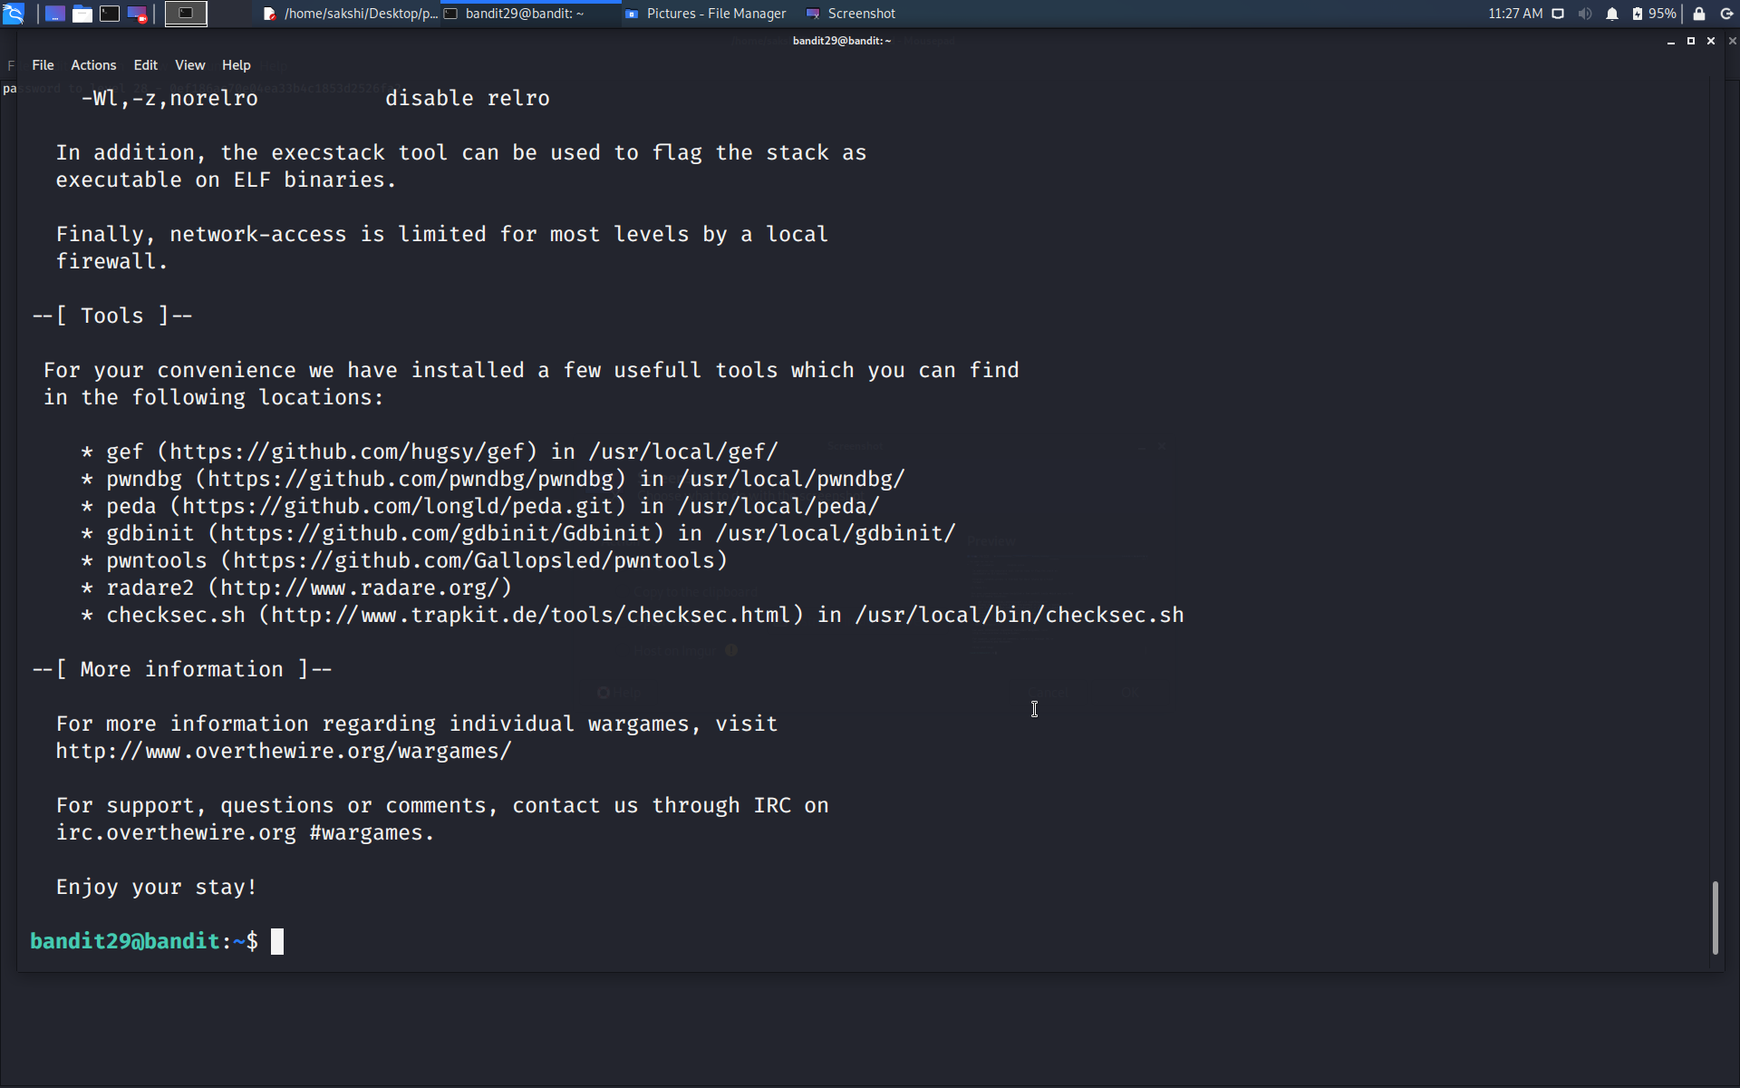

Successfully passed level 29.…